

Centre Name: ACE-HCMC-2-FPT (VN.033)

Address: 590 Cách Mạng Tháng 8 Street, District 3, Ho Chi Minh City, Viet Nam



WEB PHOTO

SHARE

Design Document

|  |  |  |  |
| --- | --- | --- | --- |
| **Faculty:** | | **Mr. Nguyen Ngo Phuoc** |  |
| **Batch No:** | | **F2-10-1203-T0** |  |
| **Group No:** | | **01** |  |
| **Student** |  | **Full Name** | **Roll No.** |
|  | 1. | NGUYEN VU HUNG | STUDENT636555 |
|  | 2. | TRAN VAN HAI | STUDENT630717 |
|  | 3. | LE NGOC NHUT | STUDENT636217 |
|  | 4. | NGUYEN ANH TUAN | STUDENT576665 |

September 2013

# Table of Contents

Table of Contents 2

I. Acknowledgment 6

II. Problem Definition 7

1. Introduction 7

2. Existing Scenario 7

III. Customer Requirement Specification 9

1. Customer Requirement Specification: 9

2. Functional Requirements Specification 9

3. Hardware / Software Requirements 9

3.1. Hardware Requirements 9

3.2. Software Requirements 9

IV. Task sheet review 1 11

I. Architecture & Design of the Project 13

1. Presentation Tier: 14

2. Business Logic Tier: 14

3. Data Access Tier: 14

II. Algorithms - Data Flowchart: 15

1. Login process 15

2. Logout process 16

3. Insert process 17

4. Update process 18

5. Delete process 19

6. Search process 20

III. Data Flow Diagram 21

1. Context Level Diagram 22

2. Level 0 DFD 23

3. Level 1 DFD 23

4. Process Decomposition 23

IV. Use Case Diagram 24

V. Sequence Diagram 25

VI. Entity–Relationship Design 25

1. Entity–Relationship Diagram 25

2. Entities and Properties 25

VII. Task sheet review 2 25

I. Database Design 28

1. Database Relationship Diagram (DRD) 28

2. Database Structure 28

3. Database Constrains 28

II. GUI Designs – Front-End 28

III. GUI Design – Back-End 29

IV. Sitemap 30

1. Front-End Sitemap 30

2. Back-End Sitemap 31

V. Task sheet review 3 32

REVIEW I

# Acknowledgment

We would like to acknowledge all those who have given support and help us make the project a success.

We wish to express our deep gratitude to all teachers who have been devoting their lives to teach us how to stand-alone and walk ahead.

We are grateful to our families who take care and encourage us even though we are successful or failed, also to our friends who are always care of us. They never leave us alone and always look forward to us when we are on any road of the life.

We are much thankful to the entire staff and chairpersons at the Head Office of Aptech Worldwide, Aptech – Vietnam, and FPT – Aptech Center who have been organizing and looking after our studying course.

There are no words to show our appreciation for teachers of FPT Aptech Centre who have been organizing and looking after us during our studying course to finish this project. Our special thanks not only Mr Nguyen Ngo Phuoc who works day by day to teach and guide us in our travel to discover the wonder of Java Programming Language but also mentors in e-Project Team at the Head Office who instruct and help us.

Finally, we would like to offer many thanks to all our schoolfellows for their valuable suggestions.

We would like to thank sincerely!

Group 1 – FPT Aptech.

# Problem Definition

## Introduction

- Our company specializes in website design for all to share photos ,if you are a true paparazzi, photographer or tweezers, sometimes you have the image inside the family

or the exchange of the friends that need to be shared , with others or simply want to share the rare moments in your own life.

Come to the photo sharing service of our.

Our service allows you to download favorite pictures on our website and shared for everyone to members of our,and watch and enjoy, and comment

You simply log in through computer or service the phone that could connected iternet be able to enjoy all the pictures of the people want to share with you.

at the same time, we also equipped

- friendship

- Creating picture information

- Comment image

## Existing Scenario

Our client has a passion of collecting various kinds of pictures. He is having a large collection of photographs of nature, sceneries, miscellaneous ones, and the wild animal s photographs, etc. He now wants to share his collection with every one. And so he has approached us for building the site for him, where the picture files can be uploaded, and viewed on the site (i.e., downloaded from the site). He also wants the users of the website to be able to upload the file, there by providing the facility of sharing the pictures of sceneries, miscellaneous pictures, etc. with the help of the site.

So he has approached us for helping him by building a website through which the pictures can be uploaded over the site.

# Customer Requirement Specification

## Customer Requirement Specification:



## Functional Requirements Specification

The system must provide a page to allow guest create register or login with the following information:

Name ,username,password ,Emails, Address,Gender ,Birthday;

### Functional Requirements

User must provide Username, Password, Name, Birthday, Gender, Address, Email to create an account email is unique

## Customer can login

The system must provide a page to allow Customer login

### Functional Requirements

Customers must provide Username and Password to login into the website.

**After login Customer can**

***Upload the picture files***

**View the picture files**

**Delete the picture files (the user can only delete the files which are uploaded by him)**

**• About the Site**

**• Feedback**

**• FAQ s**

**• Contact Information**

### Functional Requirements

The system must provide a page to allow guest create Upload with the following information:

-Image name

-Discription

-ImageFile

-Collection

### Functional Requirements

The system must provide a page to allow guest shase photo with the following information:

-social network

-oder User

-share link

-Emails

### Functional Requirements

The system must provide a page to allow user contact with Admin with the following information:

-Name

-Emails

-Subject

-mesager

### Functional Requirements

The system must provide a page to allow Display :

• The details of the new pictures that are uploaded

• The details of the new users of the website (like how many have registered with the site today)

• The details of the total number of users (total number of registered users of the site)

## FAQs

## Description

System must provide to Customers a page which displays frequently questions and answers. Administrators can add, modify or delete these.

### Functional Requirements

Customers can view FAQs page.

Administrators can add, modify or delete these.

## Administrators can manage customers

### Description

System should provide for Administrators a page which allows they manage User, view User information, view Collection of User.

### Functional Requirements

Administrators can view Customer’s information.

Administrators can view Collection of User.

## Hardware / Software Requirements

### Hardware Requirements

|  |  |
| --- | --- |
| Component | Requirement |
| Server | Processor type:  Pentium III-compatible processor or faster  Processor speed:  Recommended: 2.0 GHz or faster |
| OS | Microsoft Windows Server 2003 or higher |
| Memory (RAM) | RAM:  Minimum: 512 MB  Recommended: 2.048 GB or more  Maximum: Operating system maximum |
| Hard Drive | Free space:  Minimum: 50 MB  Recommended: 50 GB or more  Maximum: Operating system maximum |

### Software Requirements

|  |  |
| --- | --- |
| Component | Requirement |
| Microsoft .NET Framework | Version 4.0 |
| Microsoft Visual Studio | Microsoft Visual Studio 2010 |
| RDBMS | Microsoft SQL Server 2008 |
| Design Tool | Adobe Photoshop CS3 |
| Editor | Adobe Dreamweaver CS3 |
| Source Version Control | TortoiseSVN 1.7 |

# Task sheet review 1

|  |  |  |  |  |  |
| --- | --- | --- | --- | --- | --- |
| Project Ref. No: 2 | Project Title:  ITM College Management | Date of Preparation of Activity Plan | | | |
| No. | Task | Actual Start Date | Actual Days | Team Member Names | Status |
| 01 | Acknowledgment | April 26, 2013 | 2 | All Members | Completed |
| 02 | Problem Definition | All Members | Completed |
| 03 | Customer Requirement | All Members | Completed |
| 04 | Function Requirement | All Members | Completed |
| 05 | Hardware/Software | All Members | Completed |
| 06 | Task sheet | All Members | Completed |

|  |  |  |
| --- | --- | --- |
|  | Prepare By: Group | Approved By: Faculty |
| Date: Apr 26, 2013 | Team Leader  Nguyen Vu Hung |  |

REVIEW II

# Architecture & Design of the Project



Three-Tier Architecture of the Project

## Presentation Tier:

Is the tier in which the users interact with an application. Presentation Tier contents Shared UI code, Code Behind and Designers used to represent information to user.

Technology:, DHTML, CSS, JavaScript, Ajax

## Business Logic Tier:

Is mainly working as the bridge between Data Tier and Presentation Tier. All the Data passes through the Business Tier before passing to the Presentation Tier.

Technology: OOP,

## Data Access Tier:

Is basically the server which stores all the application’s data. Data tier contents Database Tables, Database Views and other means of storing Application Data.

Technology: SQL Server, LINQ, ADO.NET

# Algorithms - Data Flowchart:

Symbol generates:



## Login process



## Logout process



## Insert process



## Update process



## Delete process



## Search process



# Data Flow Diagram

Define: Data Flows Diagram (DFD) describes the information flow in the system. The next step of system analysis is to consider in detail the information necessary for the implementation for functions discussed above and the one necessary for the improvement of the functions. Modelling tool frequently used for this purpose is DFD. DFD will support 4 main activities:

Analysis: DFD is used to determine requirement of users.

Design: DFD is used to map out plan and illustrate solution to analysis and users while designing a new system.

Communication: one of the strength of DFD is its simplicity and ease to understand to analysts and users;

Document: DFD is used to provide special description of requirement and system design. DFD provide an overview of key functional components of the system but it does not provide any detail on these components. We have to use other tools like database dictionary, process specification to get an idea of which information will be exchanged and how.

The main components of Context Diagram:

|  |  |  |
| --- | --- | --- |
|  | External | The process: Shows the common function of system  The external factors: External factors can be a person, a group of persons or an organization that are sources of information for the systems and are where system products are transferred to.  The data flow: Describe the movement of information from one part of the system to another.  The data store: The Data Store is used to model a collection of data packets at rest. A store is represented graphically by two parallel lines. The name of a Data Store that identifies the store is the plural of the name of the packets that are carried by flows into and out of the Data Store |
|  | The process |
|  | Data flow |
|  | Data store |

## Context Level Diagram

## Level 0 DFD

## Level 1 DFD

## Process Decomposition

# Use Case Diagram

# Sequence Diagram

Login

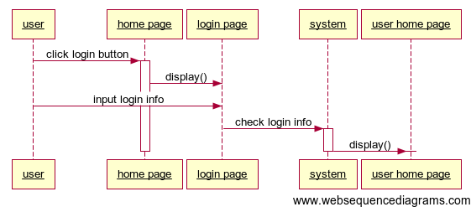

ShareImage

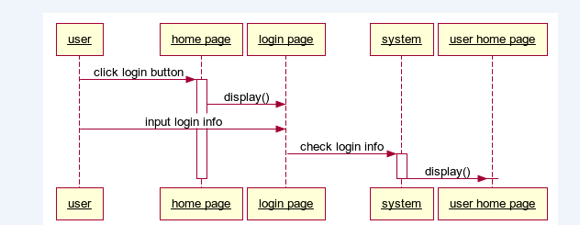

SendImage

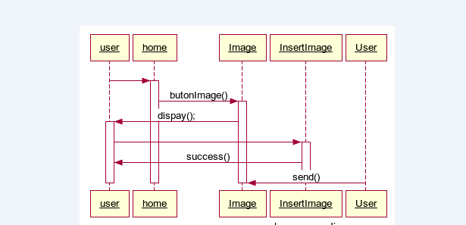

CreateCllection

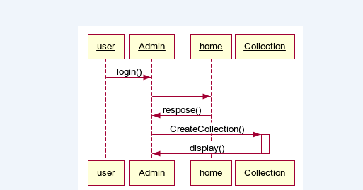

Create FAQs

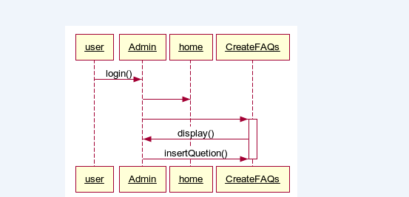

AnswerFeedback

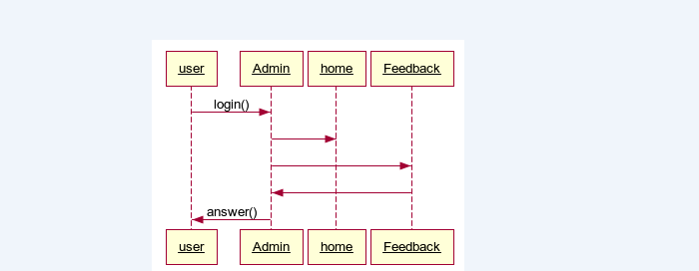

# Entity–Relationship Design

## Entity–Relationship Diagram

## Entities and Properties

# Task sheet review 2

|  |  |  |  |  |  |
| --- | --- | --- | --- | --- | --- |
| Project Ref. No: 2 | Project Title: | Date of Preparation of Activity Plan | | | |
| No. | Task | Actual Start Date | Actual Days | Team Member Name | Status |
| 01 | Architecture & Design of the Project | May 04, 2013 | 6 |  |  |
| 02 | Algorithms - Data Flowchart |  |  |
| 03 | Data Flow Diagram |  |  |
| 04 | Use Case Diagram |  |  |
| 05 | Sequence Diagram |  |  |
| 06 | ERD |  |  |

|  |  |  |
| --- | --- | --- |
|  | Prepare By: Group | Approved By: Faculty |
| Date: May 04, 2013 | Team Leader  Nguyen Vu Hung | Tran Phuoc Sinh |

REVIEW III

# Database Design

## Database Relationship Diagram (DRD)

## Database Structure

## Database Constrains

# GUI Designs – Front-End

# GUI Design – Back-End

# Sitemap

## Front-End Sitemap

## Back-End Sitemap

# Task sheet review 3

|  |  |  |  |  |  |
| --- | --- | --- | --- | --- | --- |
| Project Ref. No: 2 | Project Title: | Date of Preparation of Activity Plan | | | |
| No. | Task | Actual Start Date | Actual Days | Team Member Name | Status |
| 01 |  | May 04, 2013 | 10 |  |  |
| 02 |  |  |  |
| 03 |  |  |  |
| 04 |  |  |  |

|  |  |  |
| --- | --- | --- |
|  | Prepare By: Group | Approved By: Faculty |
| Date: | Team Leader  Nguyen Vu Hung |  |